Tracker Quick-Look Operator Manual

Authors
Fedele D., Vannuccini E.

(v 1.00)

1 Tracker Quick-Look Programs 1
2 BASIC LEVEL 2
2.1 TrkCalibQLookBasic 2
2.2 TrackerQLookBasic 3

Tracker Quick-Look Programs
List of programs for automatic Quick-Look of tracker:

- BASIC LEVEL
- TrkCalibQLookBasic Basic Tracker calibration data analysis
- TrackerQLookBasic Basic Tracker physics data analysis

- EXPERT LEVEL
- TrkCalibQLookExpert More detailed Tracker calibration data analysis
- TrackerQLookExpert More detailed Tracker physics data analysis

The operator have to look only the BASIC LEVEL output to take an action.

BASIC LEVEL

TrkCalibQLookBasic
Produces one or more files (jpg,gif,ps or pdf) depending on the amount of errors and the chosen output format:
- Description: The program verifies if the calibration is good, by checking the calibration packet crc, the calibration flag and by comparing the mean value for sigma and pedestal with some reference values.
- NOMINAL: all crc and flag values are zero and the mean value of sigma and pedestal are within the limits.
- STANDARD: Neither calibration errors nor warnings are found; a black writing sais “OK”.
  - NO ACTION to be taken.
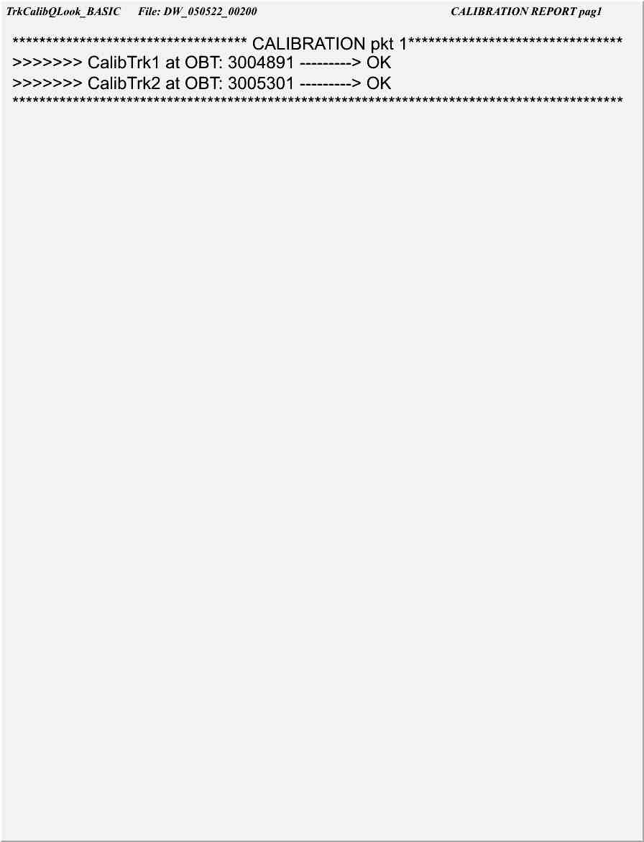
figure 1: Example of a good calibration packet
- NON-STANDARD: some red writings indicate which problem occurred.
  - ACTION: call specialist.
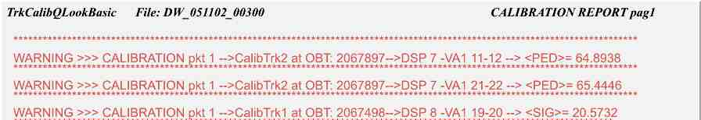
figure 3: Example of a warning condition due to anomalous sigmas and pedestals
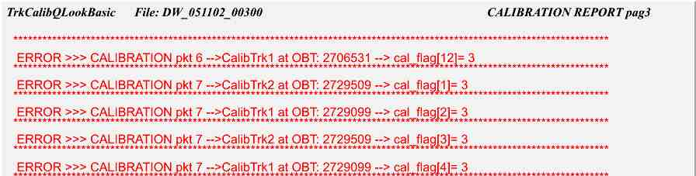
figure 2: Example of an error condition

TrackerQLookBasic
Produces one file (jpg,gif,ps or pdf):
- Description: Plot of data-length versus OBT for each DSP; The start time of each run is indicated by vertical lines together with the type of calibration which is associated to the run (D = default calibration, 1= on-line normal calibration or 2 = on-line special calibration).
- NOMINAL: the value in the graph must be below the lower horizontal line or above the higher horizontal line.
- STANDARD: less then 1% of the values are in the forbidden zone for each DSP. The picture is black and white.
  - NO ACTION to be taken.
- NON-STANDARD: more then 1% of the values are in the forbidden zone for one or more DSP. The corresponding pad is red.
  - ACTION: call specialist.
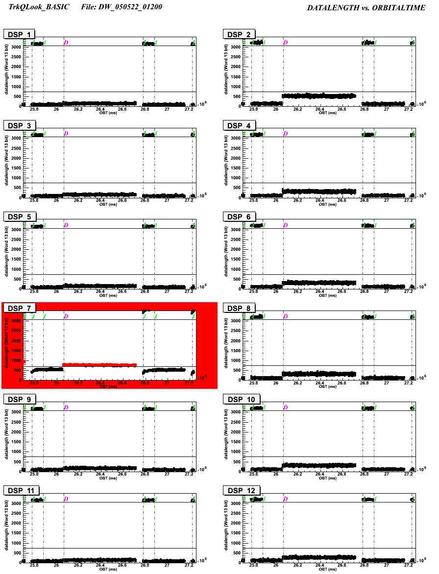
figure 4: Example of a run showing a non standard behaviour for DSP 7. NB: the limits(=700) for DSP 7 in this figure is lower then normal(=1500) to show a non-standard situation.

