Appendix C.XX: The Anticounter QuickLook Operators Manual

‘AcQLOOk’ script
Produces a single output file (jpg, gif, ps or PDF), depending on the user’s selection.

- Description: The anticounter quicklook script checks (a) the number of hits registered by the photomultiplier tubes during the run in question. (b) the contents of the status register. The output is divided into two columns, one for each data acquisition board (‘main’ and’extra’).
- Nominal: There should be activity registered by all photomultiplier tubes and the value returned by the status register should be zero.

- Standard operation: No deviation from the nominal condition is identified, see figure 1.
  - Action: Do nothing.

- Non-standard operation: The nominal condition is not fulfilled, see figure 2.
  - Action: Contact the anticounter specialist (see below)

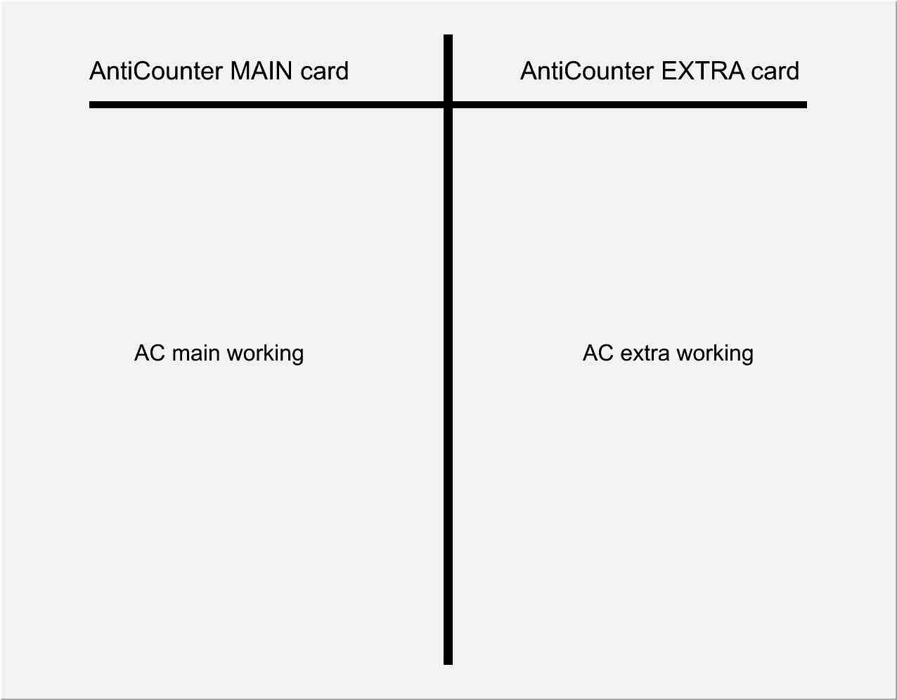
Figure 1: The output of the anticounter Quicklook script for nominal operation.

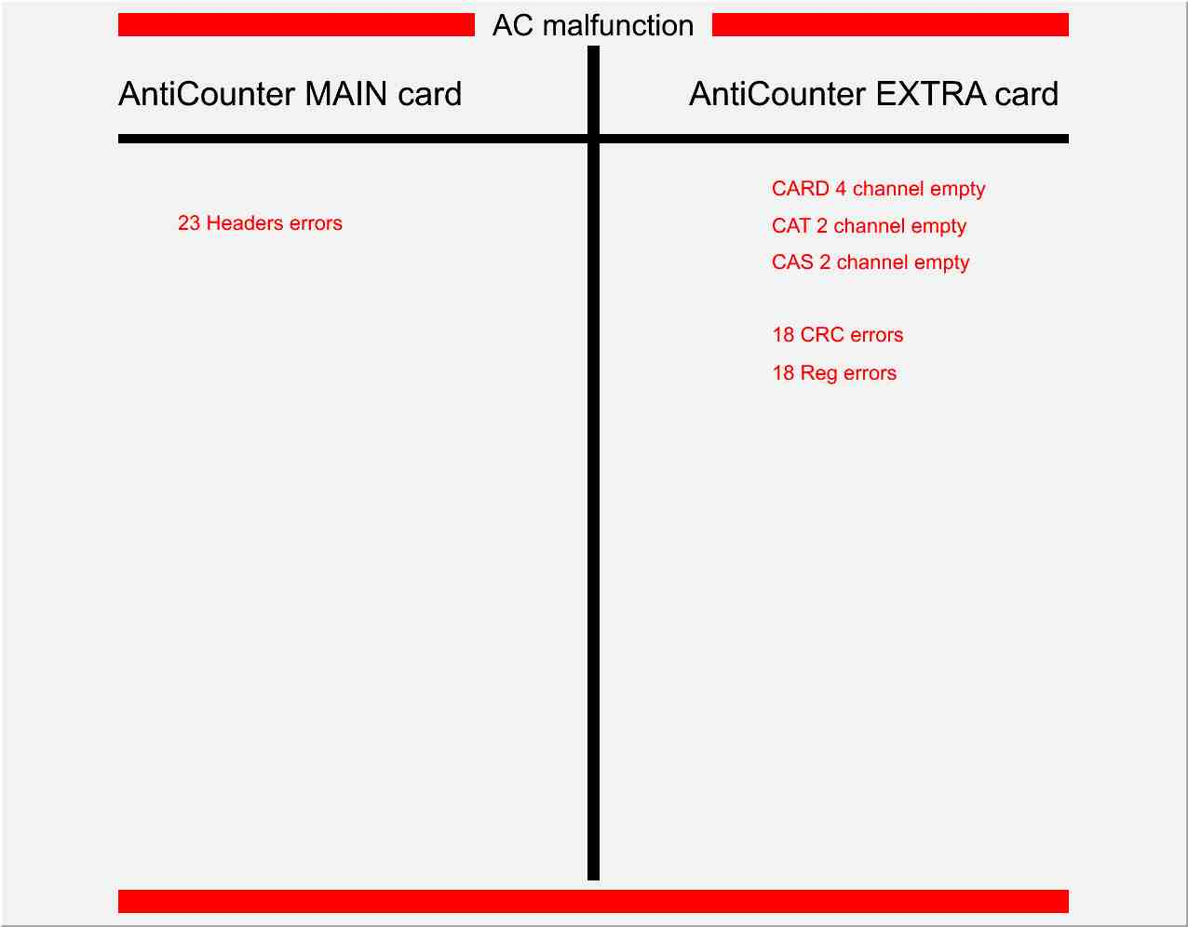

Figure 1: The output of the anticounter Quicklook script for non-standard operation. In this case, the ‘main’ board has 23 ‘header’ errors from the status register and the ‘extra’ board has three photomultipliers which have registered no activity and 18 ‘CRC’ and 18 ‘Reg’ errors from the status register.

Anticounter specialists
Note: The anticounter specialist currently on call is listed at: http://www.particle.kth.se/pamela/AC-on-call.
Only if this webpage is not accessible should the following list be used.

- Petter Hofverberg (pth@kth.se).
Office tel: +46-8-55378186. Mobile: +46-70-3917233.
- Silvio Orsi (silvio@particle.kth.se).
Office tel: +46-8-55378217. Mobile: +46-73-9775733.
- Mark Pearce (pth@kth.se).
Office tel: +46-8-55378183. Mobile: +46-73-6423929.

Contact person for QuickLook software
- Petter Hofverberg (pth@kth.se).
Office tel: +46-8-55378186. Mobile: +46-70-3917233

