The S4 Quick-look Operational Manual

Laura Marcelli – Valeria Malvezzi

June 2006
(Software v. 1.1)

Introduction

The aim of this document is to describe the output of the S4 Detector quick-look software.
Each input parameter and each output figure are described, and a brief description on how to recognize possible problems is reported.

List of programs for automatic QuickLook of S4:

- S4_QL: for S4 data

- S4_Calibration_QL: for S4 calibration data

Software description

Function: S4_QL (TString base, TString outDir, TString format, ULong_t DeltaT)

Brief function description:

The aim of S4 QL software is to monitor the behaviour of this detector.
It creates three output canvases: the first one contains the histogram of S4 data, the second one is relative to the time behaviour of collected data while the last shows s4 rate (information from Trigger Packet)
See below for a more detailed description of the output.

Parameters:

TString base - the path to the root directory for the specific Pamela unpack session. There is no default value, without this input the program will not run.

TString outDir - the path where to save the output image (Default = “./”)

TString format - the format which will be used for save the produced images (Default = "jpg")

Float_t DeltaT - the time interval (in minute) to hold under control time behaviour (Default value = 1 minute)

Output Description:

DW_yymmdd_xxxxx_S4_QL:
This canvas is created only if there are no entries in the root file.

S4_QL:

No entries for this file

DW_yymmdd_xxxxx_S4_QL_1:

This figure shows the histograms of ADC collected value for all triggered events (first pad) and for S4 triggered events (second pad).
S4_threshold and trigger configuration are shown in figure.

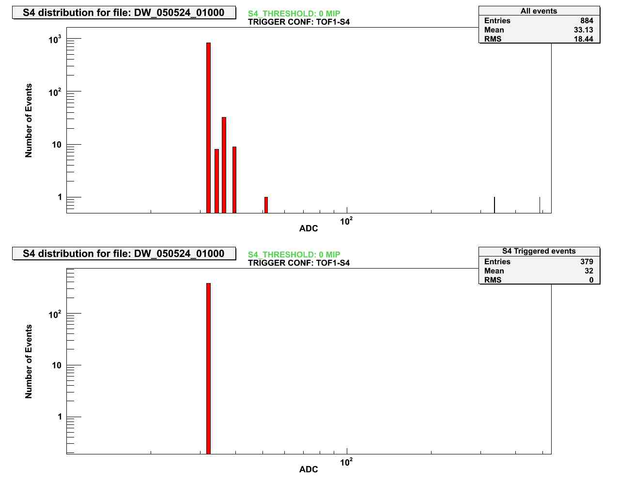

DW_yymmdd_xxxxx_S4_QL_2:

This figure shows the time evolution of S4 ADC collected values for all triggered events (first pad) and for only S4 triggered events (second pad).
In these graphs each point represents the mean of ADC values collected during the previous temporal interval. The duration of this temporal interval is set to the default value of 1 minute (but the user can change its value setting the input parameter “DeltaT”).

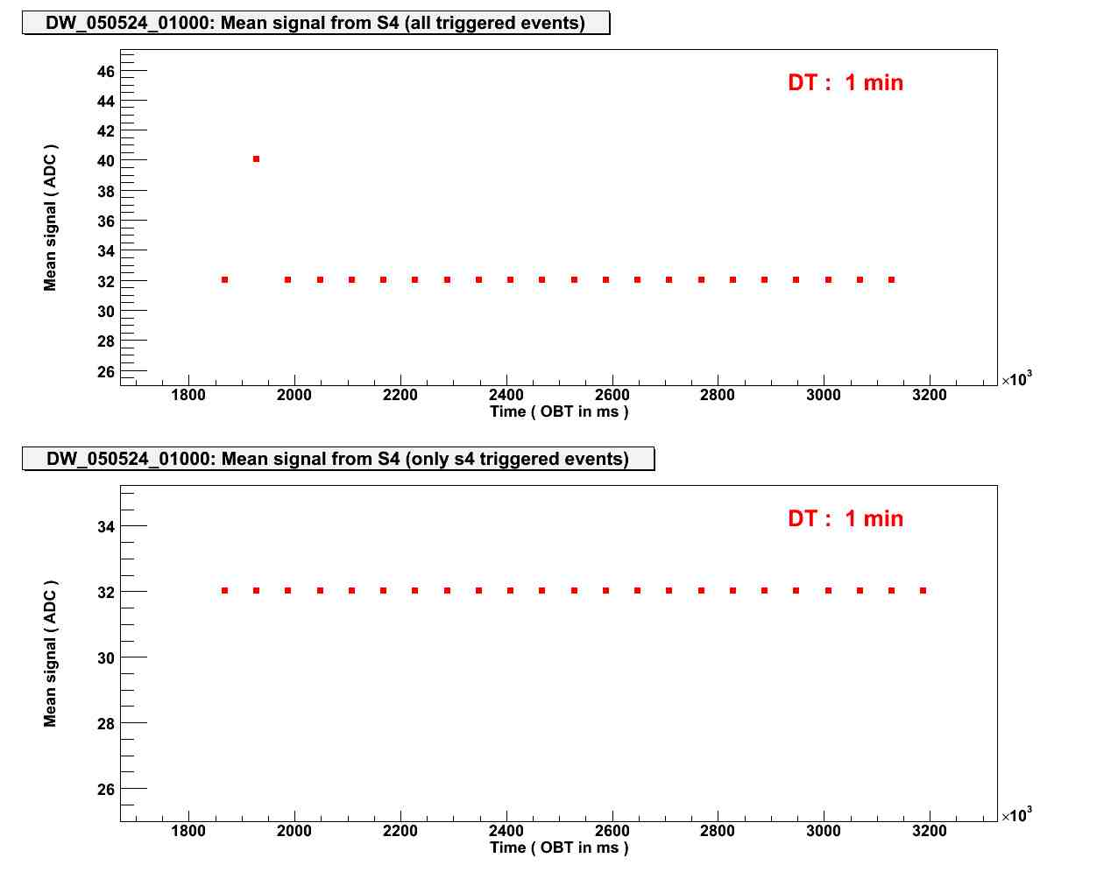

If no S4 triggered events are present the figure looks like this:

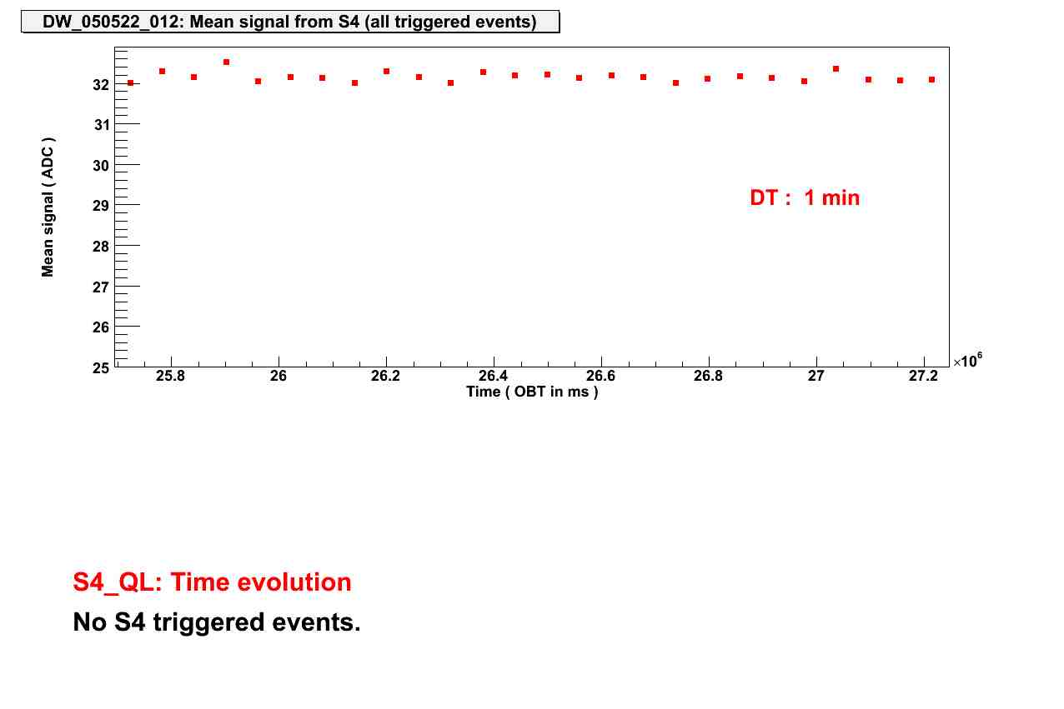

DW_yymmdd_xxxxx_S4_QL_3:

This figure shows S4 rate (in Hz) vs. OBT (On Board Time). This information is from Trigger Packet.
The bottom part of the figure shows a smoothed behaviour of S4 rate.

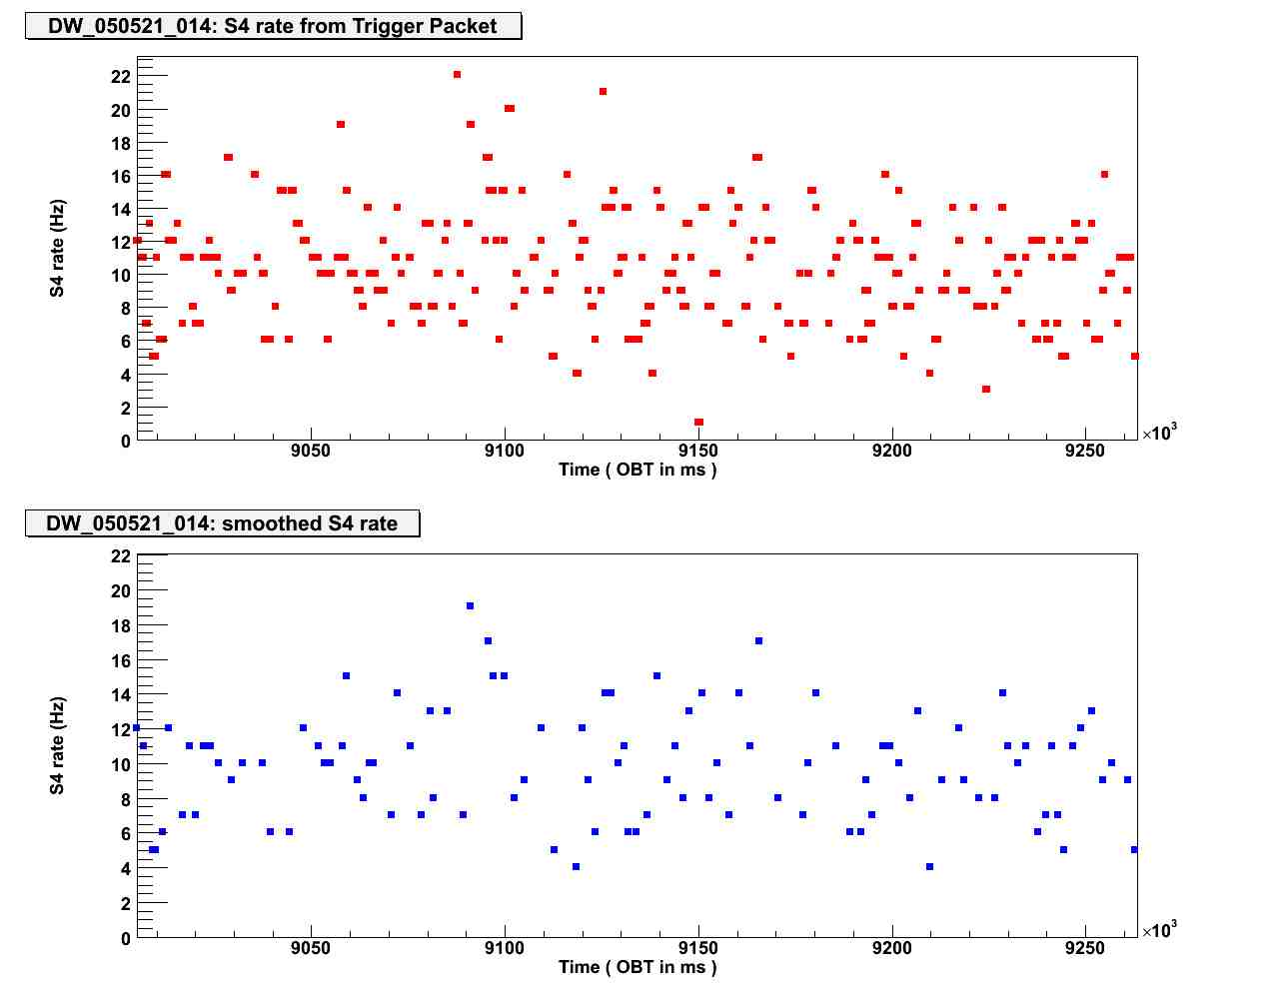

Function: S4_Calibration_QL (TString base, TString outDir, TString format)

Brief function description:

The aim of S4 Calibration QL software is to keep under control the behaviour of S4 Calibration.
It creates only one output canvas relative to the time behaviour of collected calibration data.
See below for a more detailed description of the output.

Parameters:

TString base - the path to the root directory for the specific Pamela unpack session. There is no default value, without this input the program will not run.

TString outDir - the path where to save the output image (Default = “./”)

TString format - the format which will be used for save the produced images (Default = "jpg")

Output Description:

DW_yymmdd_xxxxx_S4_Calibration_QL:

This figures shows the time evolution of S4 calibration values. The kind of calibration (hot or cold) is indicated.
A calibration event is represented by three dots (at the same OBT obviously), one for each calibration (green for the first calibration, pink for the second one and blue for the third one). Each point represents the mean value of a calibration for a particular calibration event.
The couples of lines delimit ±20% of the nominal value (different for hot and cold calibration).

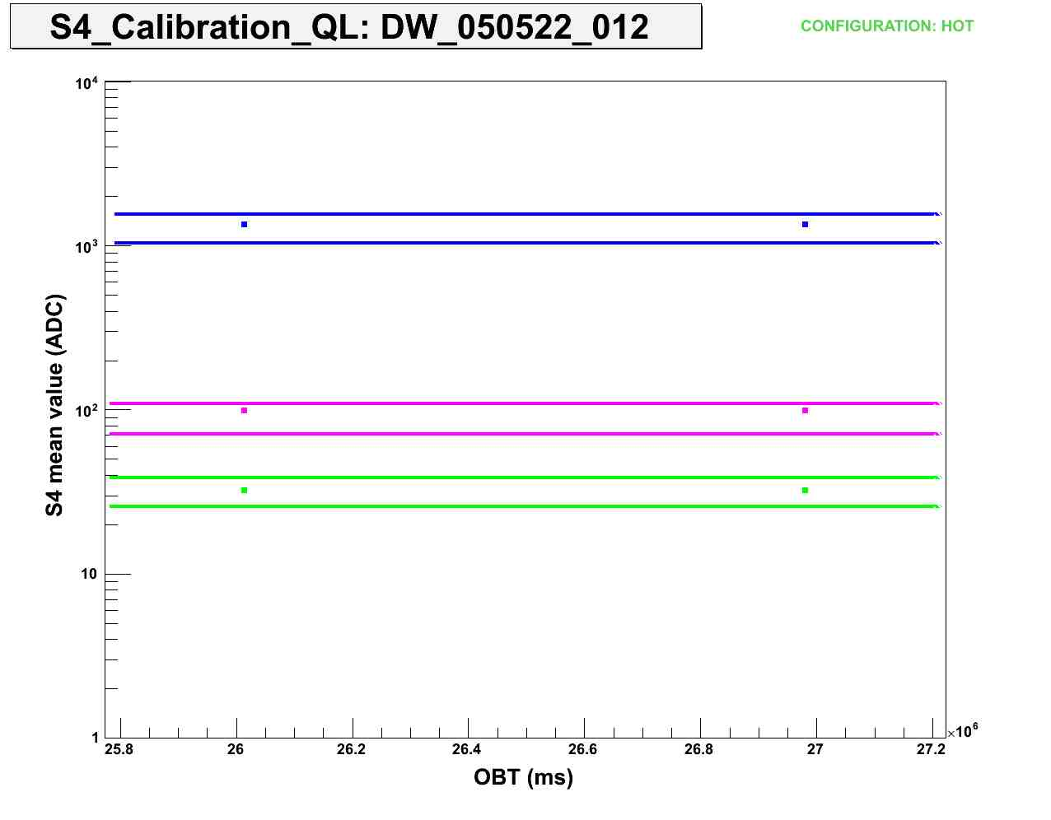

If there are no entries, the output will be follow:

