The Neutron Detector Quick-look Operational Manual

Laura Marcelli – Valeria Malvezzi

June 2006
(Software v. 1.1)

Introduction

The aim of this document is to describe the output of the Neutron Detector quick-look software.
Each input parameter and each output figure are described, and a brief description on how to recognize possible problems is reported.

Software description

Function: ND_QL (TString base, TString outDir, TString format, Float_t DeltaT, ULong_t DeltaTevtime)

Brief function description:

The aim of Neutron Detector QL software is to keep under control the time behaviour of this detector.
It creates three output canvases: the first and the second canvases are relative to Background channels, while the third one is relative to trigger events (“event” channel) instead.
Each output relates to one PAMELA marshroot. See below for a more detailed description of the output.

Parameters:

TString base - the path to the root directory for the specific Pamela unpack session: DW_yymmdd_xxxxx_ is an example for this Document. There is no default value, without this input the program will not run.

TString outDir - the path where to save the output image (Default = “./”)

TString format - the format which will be used for save the produced images (Default = "jpg")

Float_t DeltaT - the time interval in ms for ND records collection used for histograms ND_QL_1 plotting (Default value = 1000 ms)

Float_t DeltaTevtime - the time interval in minutes for calculation of average ND count rate per minute, see the ND_QL_2 and ND_QL_3 plots (Default value = 1 minute)

Output Description:

DW_yymmdd_xxxxx_ND_QL_1:
This figure shows the histograms of distributions of neutron number as recorded by the Bottom (upper pad) and the Top (lower pad) Background channels, respectively. The time interval for collection of the Background channels recording for these histograms is set to the default value of 1000 ms (but the user can change it setting the input parameter “DeltaT”). It means that each event of the histograms corresponds to the total number of neutrons collected during this temporal interval. The histograms relates to the whole time of the given marshroot.
A Poissonian fit is produced for each histogram and its statistical values are shown in the relative pad.

Situation is not normal in case all events have zero number of neutrons, i.e. the histograms have only 1 column between 0 and 1. Information should be reported to the ND responsible person.

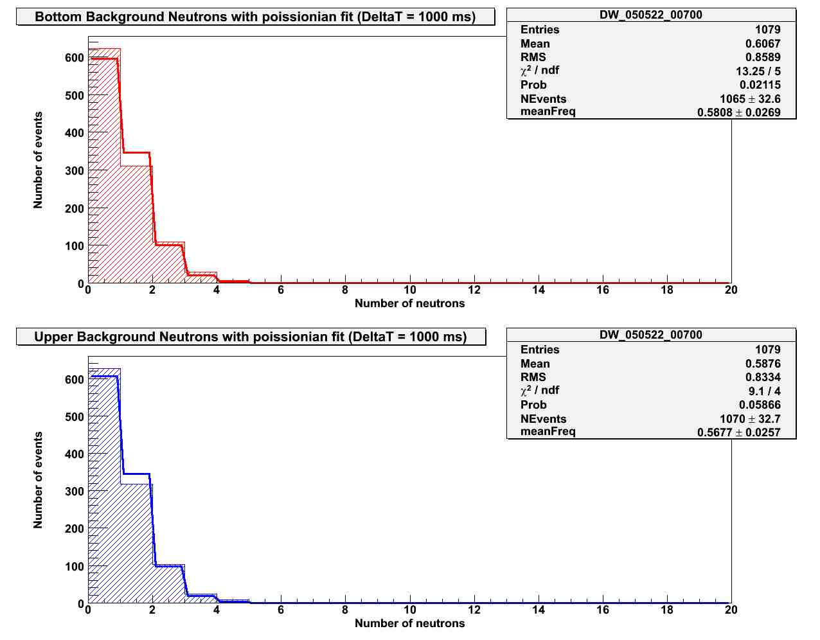

DW_yymmdd_xxxxx_ND_QL_2:

This figure shows the time evolution of the count rates per 1 minute averaged over a temporal interval “DeltaTevtime” for the Top (green points) and the Bottom (red points) Background channels (upper pad) and for the ratio of Top/Bottom Background channels (lower pad).
Points in the pads are placed at the end of each successive temporal interval. The duration of a temporal interval is set to the default value of 1 minute (but the user can change its value setting the input parameter “DeltaTevtime”).
The corridor defined by horizontal lines in the lower pad corresponds to the expected values of the Top/Bottom channels ratio given “DeltaTevtime”=1 min.

Situation is not normal in case the count rates in the Top and Bottom Background channels are strongly different so that their ratio value is beyond the corridor. Information should be reported to the ND responsible person.

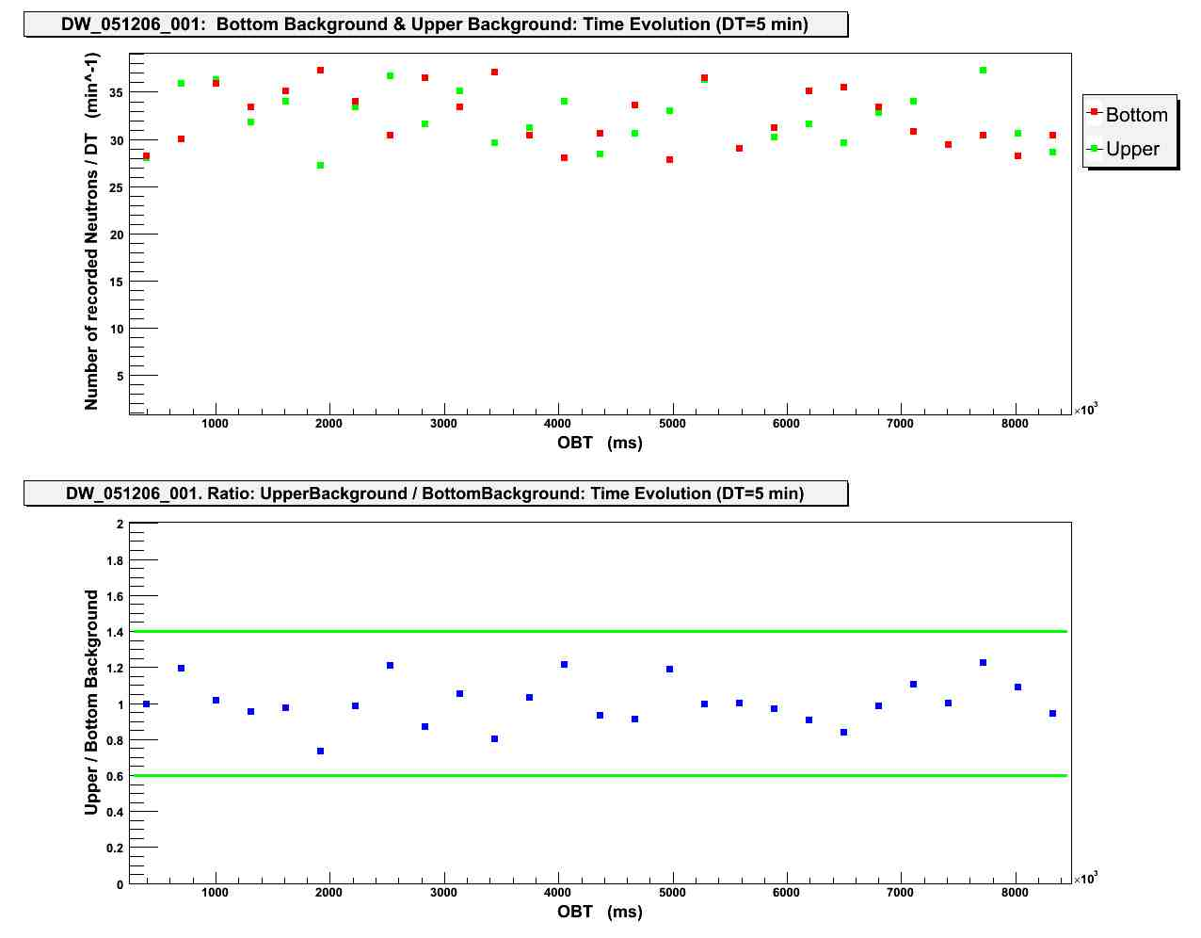

DW_yymmdd_xxxxx_ND_QL_3:

This figure shows the time evolution for trigger events. In the upper pad numbers of recorded neutrons for each trigger event are shown. In the middle and lower pads each point represents the count rate per 1 min of trigger neutrons averaged over a temporal interval “DeltaTeVtime” and is placed at the end of given interval. The difference between these two pads is that in the lower pad the points are drawn only if the count rate of trigger neutrons is greater than 10.
Like in DW_yymmdd_xxxxx_ND_QL_2, the duration of a temporal interval is set to the default value of 1 minute (but the user can change its value setting the input parameter “DeltaTevtime”).

Situation is not normal in case there are no trigger events at all or the number of neutrons in the trigger events is permanently more than 10. Information should be reported to the ND responsible person

