QtoInc.

It’s first realize of QtoInc. It’s program for calculating direction of particles flight into Pamela detector, calculating of pitch angles, zenit and azimuth angles etc. It can to calculate Pamela’s.
There is some outputh picture:

Pitch exposition.
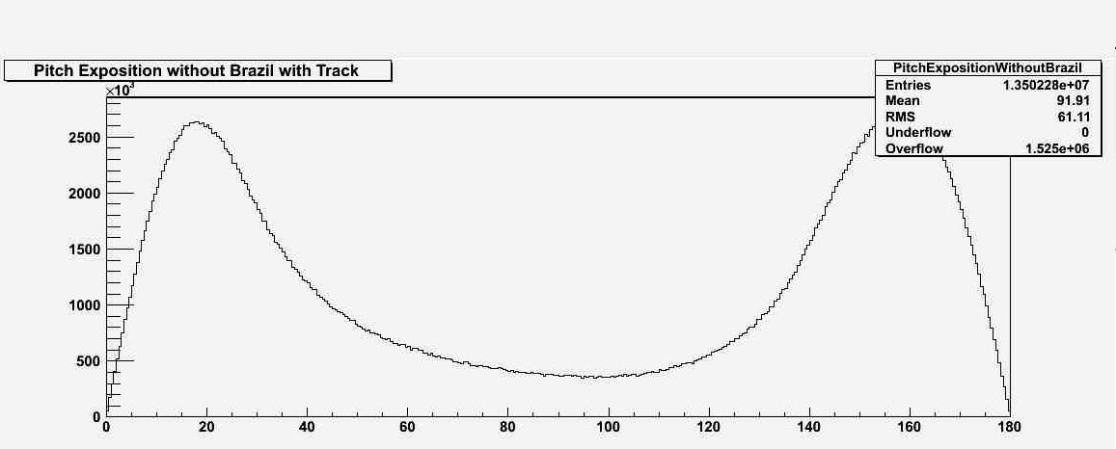

Here is difference between hystogramm of Pitch Angle distribution getting using quaternions
and not using it.
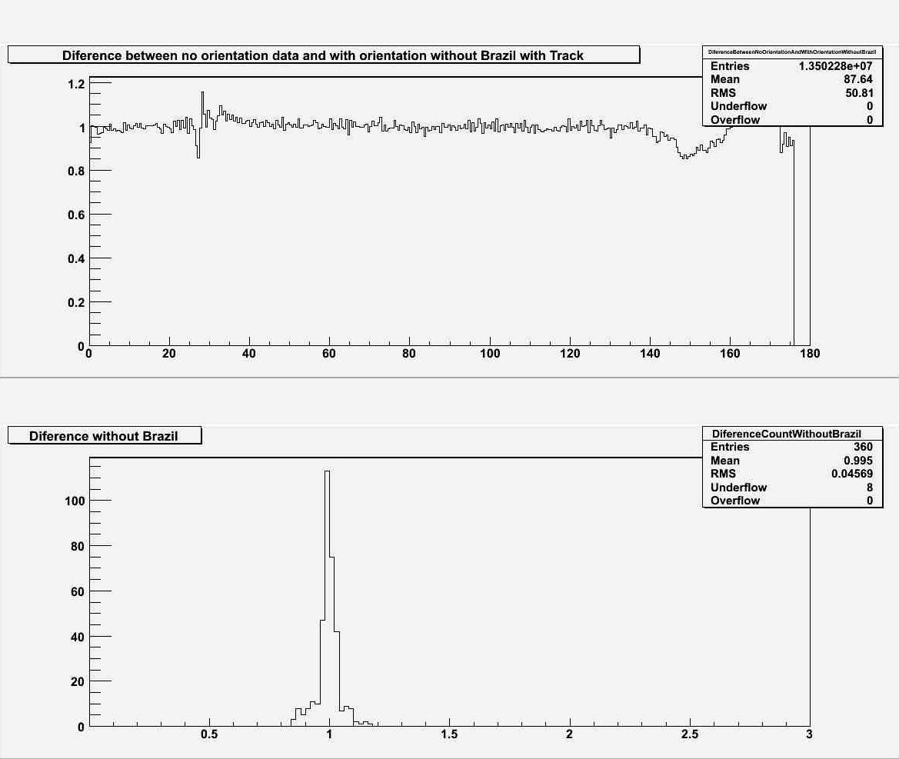

Angular distribution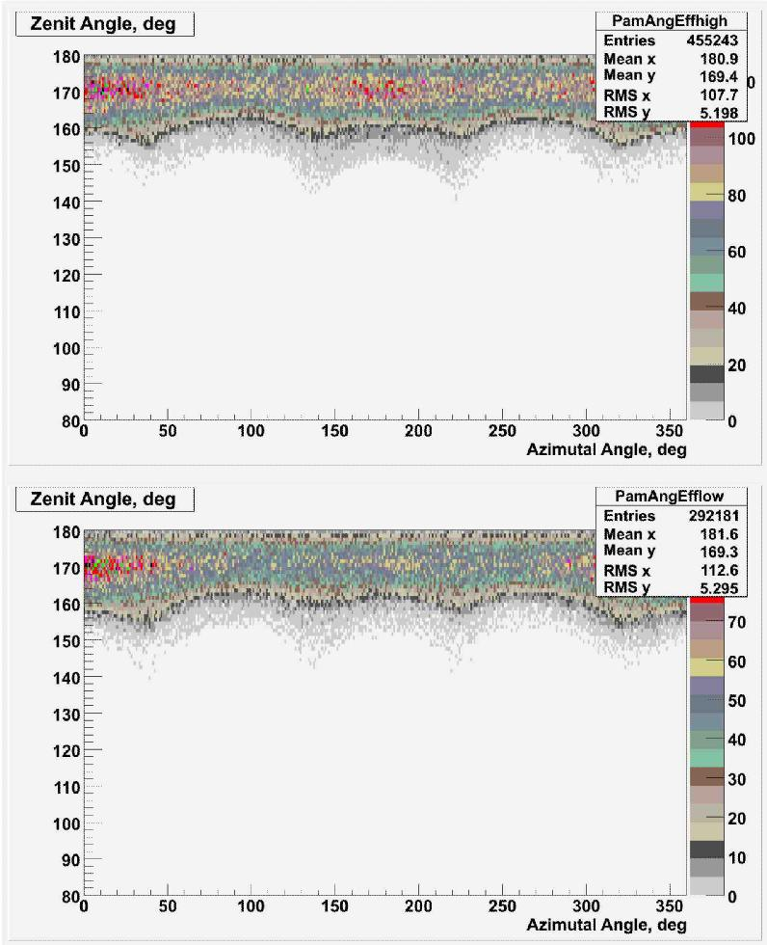

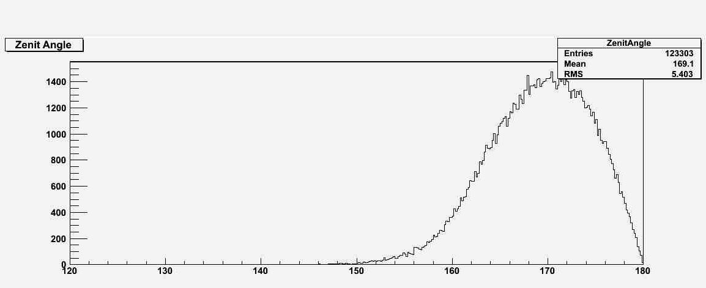

Zenit Angle distribution.

To get more information for run programm use --help option.

To setup program use make-command.

NOTE: To correct work necessary to change puth to the PAM_CALIB-directory in QtoInc.cpp in 136th line.

